Que1. find top 3 outlets by cuisine type without using limit and top function

with cte as(

select cuisine,restaurant_id,count(*) as no_of_orders

from orders

group by cuisine,restaurant_id

)

select * from(

select*

,row_number()over(partition by cuisine order by no_of_orders desc)as rn

from cte)

where rn<=3;

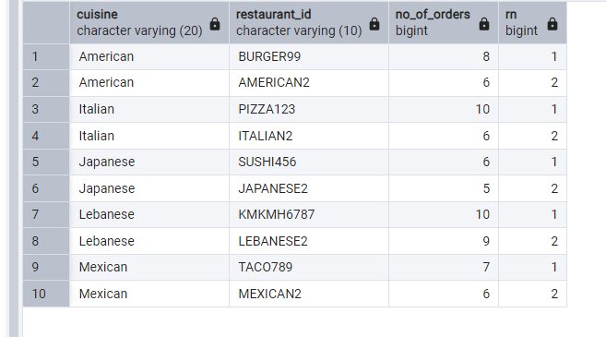

Que 2.find out daily new customer count from the launch date(everyday how many new c

customers are we acquiring)

with cte as(

select customer_code,cast(min(placed_at)as date)as first_order_date

from orders

group by customer_code)

select first_order_date,count(*)as no_of_new_customers

from cte

group by first_order_date

order by first_order_date;

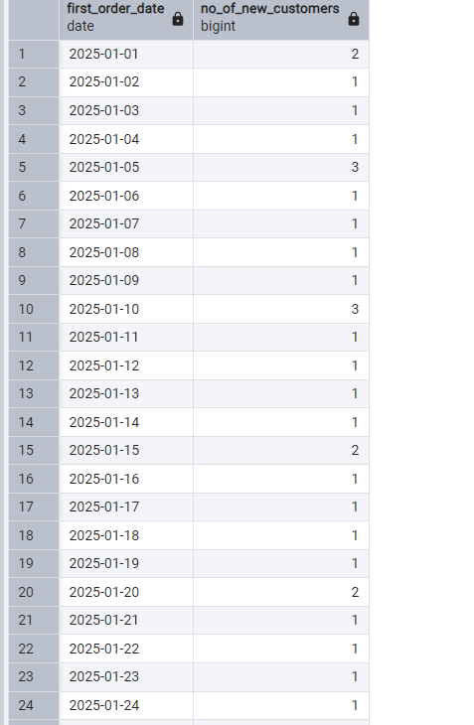

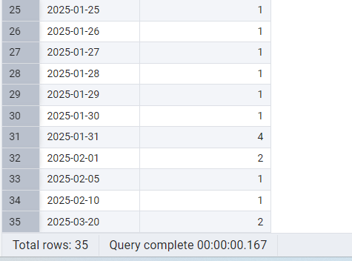

Que 3-count of all users who were acquired in jan 2025 and only placed one order in jan and did not place any other order

select customer_code,count(*)as no_of_orders

from orders

where extract(month from placed_at)=1 and extract(year from placed_at)=2025

and customer_code not in (select distinct customer_code

from orders

where not (extract(month from placed_at)=1 and extract(year from placed_at)=2025)

)

group by customer_code

having count(*)=1;

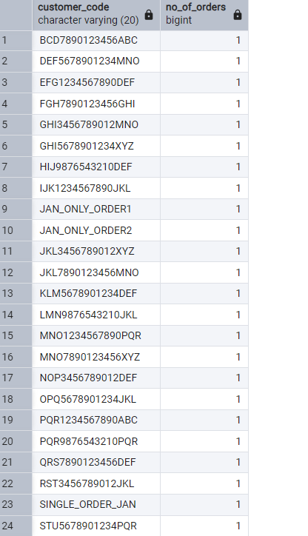

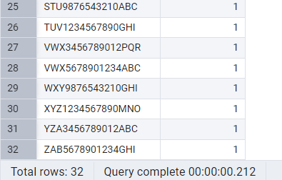

Que 4-list all the customer with no orders in last 7 days but were acquired one month ago with with thier first order on promo

with cte as(

select customer_code,min(placed_at)as first_order,max(placed_at)as lastest_order

from orders

group by customer_code

)

Select cte.customer_code,cte.first_order,cte.lastest_order,orders.promo_code_name as first_order_promo

from cte

join orders

on orders.customer_code=cte.customer_code

and orders.placed_at=cte.first_order

where cte.lastest_order< current_date-interval'7 days';

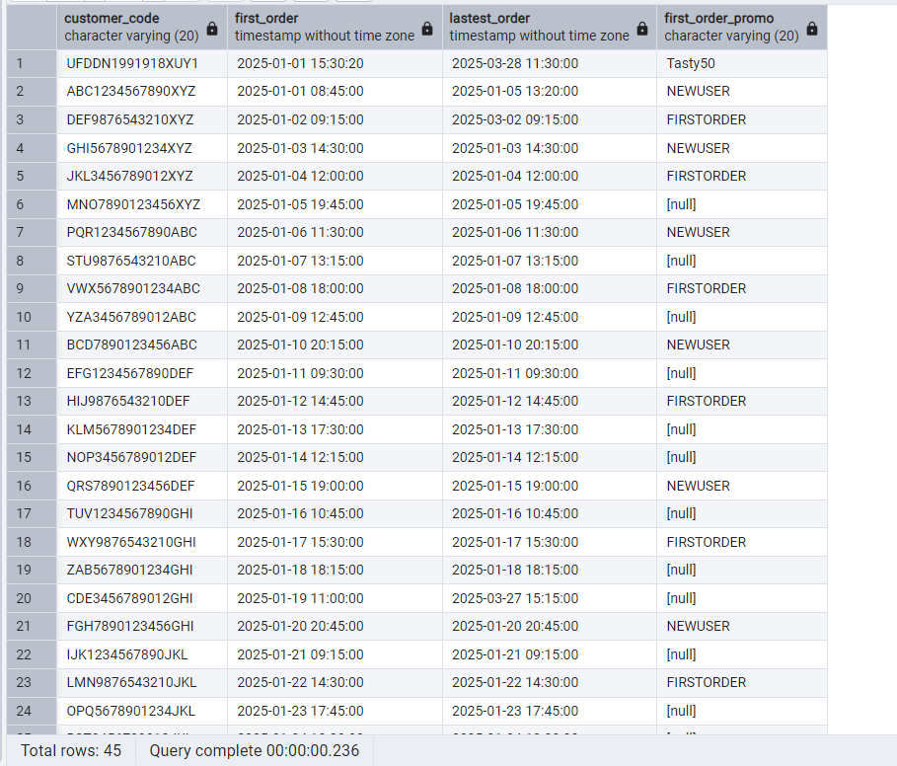

Que 5-growth team is planning to create a trigger that will target customers after their evey third order with a personalized communication and they have to create a query for this

with cte as(

select*,

row_number()over(partition by customer_code order by placed_at)as order_num

from orders)

select * from cte

where order_num%3=0 and placed_at::date= date'2025-03-31';

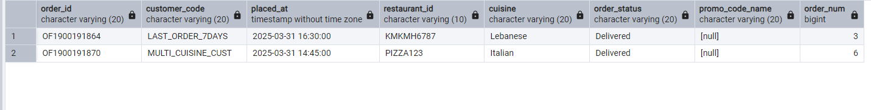

Que- 6-list csutomers who placed more than 1 order and all their orders on a promo only

select customer_code ,count(*)no_of_orders,count(promo_code_name)as promo_orders

from orders

group by customer_code

having count(*)>1 and count(*)=count(promo_code_name);

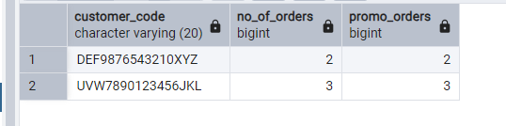

Que 7-what percent of customer were organically aquired in jan 2025.(placed their first order without promo code)

with cte as(

select*

,row_number()over(partition by customer_code order by placed_at)as rn

from orders

where extract(month from placed_at)=1 and extract(year from placed_at)=2025

)

select round(count(case when rn =1 and promo_code_name is null then 1 end) * 100.0/count(distinct customer_code),2)

as organic_acquired_percentage

from cte;

